**Dairy farm management system**

**Group members:**

M. Soban Rafique

Syed M. Ali Kazim

**Introduction:**

We designed a website for dairy farm owners. In which he first has to login by entering his name and password. Then he can keep the records of the workers and on the next page he can keep the records of the customers then on the last page he can the keep the records of all his sales. The main purpose of our website will be that a dairy farm owner can keep all their records in one place. And he doesn’t have to carry any records notebook with him and can see his records anywhere on any device any time.

**Figma:**

In this project first we design a website on figma. In figma, Soban has designed the login page and Ali has design the record pages. And then together we both makes some edits in all the pages. Here are some screenshots of our figma design:

**Login Page:**

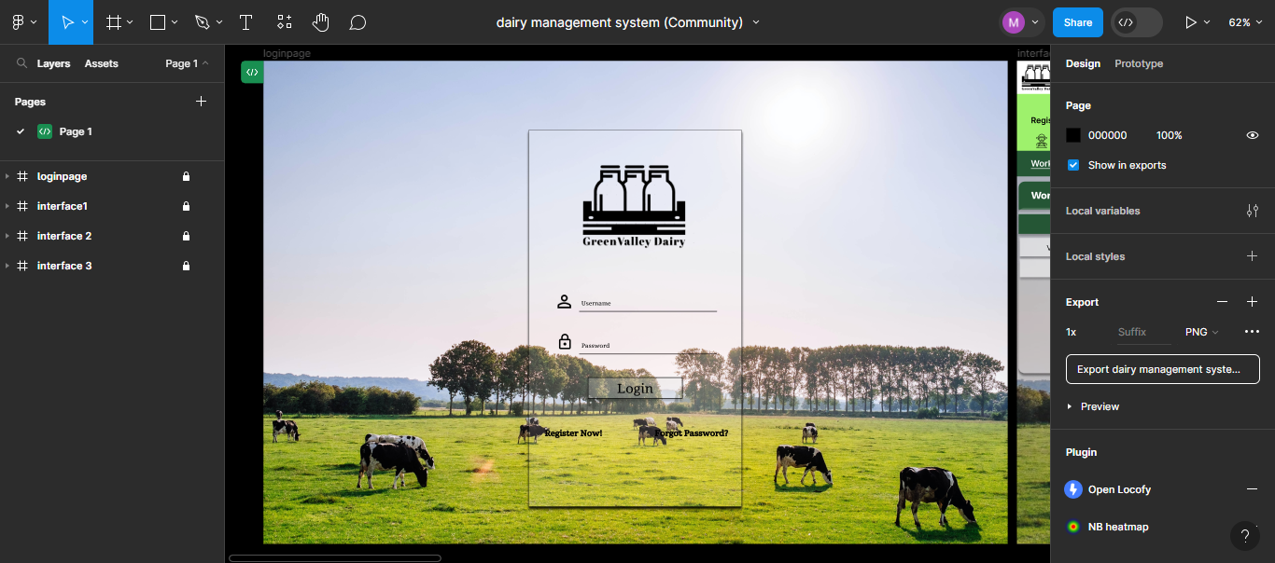

**Workers Records:**

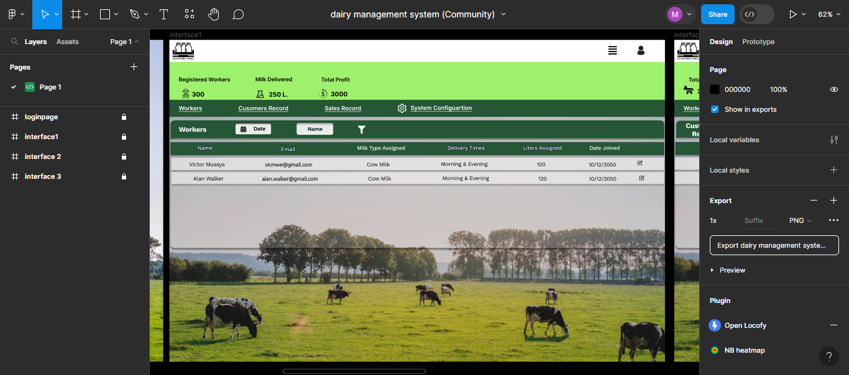**Customers Records:**

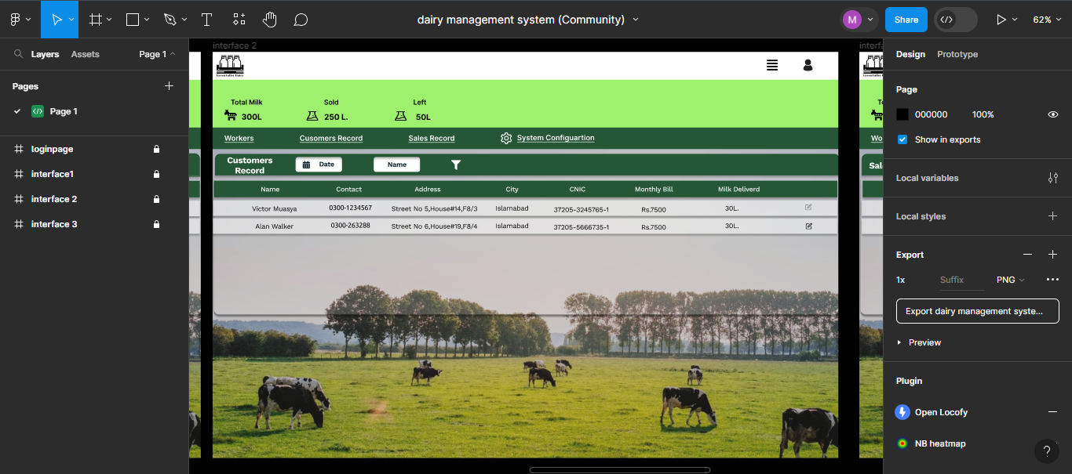

**Sale Records:**

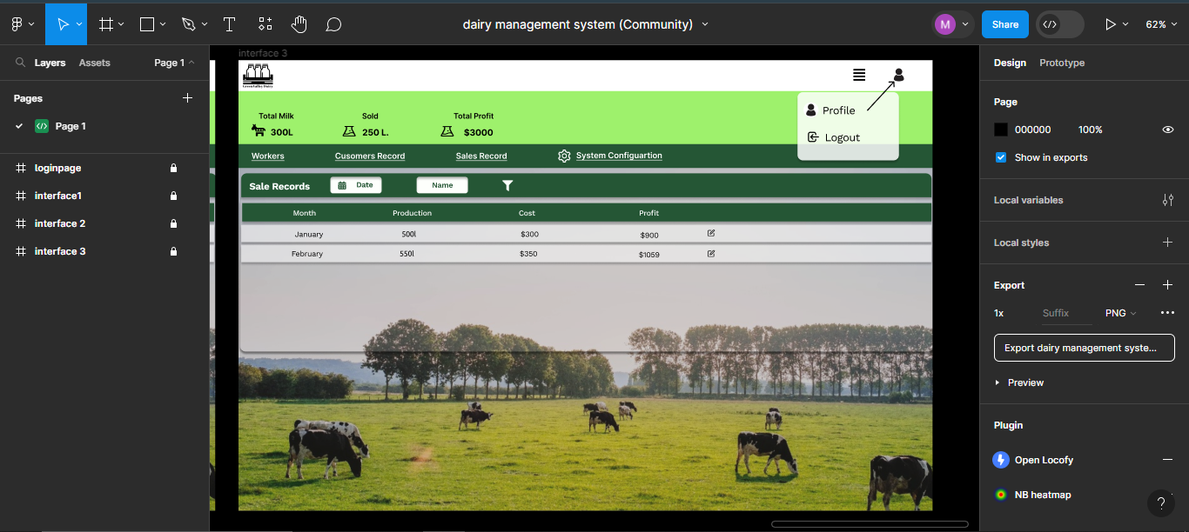

**Front end:**

In this part, Soban Designed the login page by using “html” and “CSS”. First, he made the login page using html and then designed it by using CSS. Then the next pages are designed by Ali. He also designs the record pages in the same page. So, “Login page” is designed by Soban and “record page” is designed by Ali Kazim.

**Back end:**

Unfortunately, we could not develop the backend of this website.